Task 6:
- Person:
package task6;

public class Person {

private String name;
private int age;

public Person(String name,int age) {
this.name =name;
this.age =age;
}

public String getname() {
return name;
}

public int getage() {
return age;
}

public static void main(String[] args) {
Person person = new Person("lakshmi", 30);

System.out.println("The name of the person is " + person.getname());
System.out.println("The age of the person is " + person.getage());

}

}
O/P:
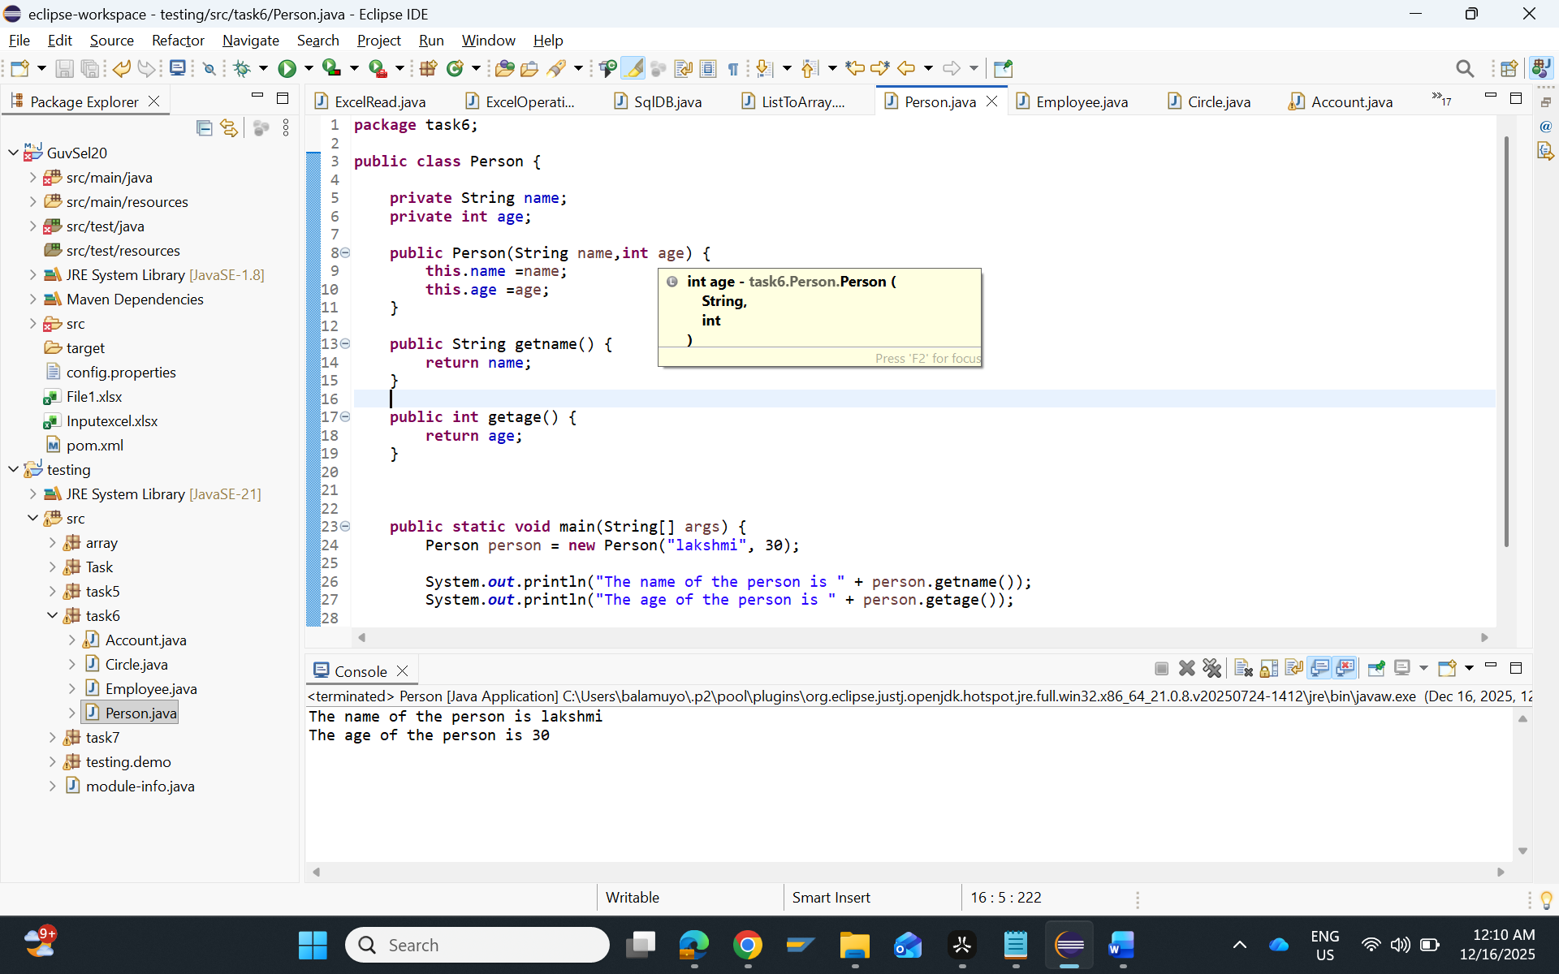

- Employee:
package task6;

public class Employee {

private int id;
private String firstname;
private String lastname;
private int salary;

public Employee (int id, String firstname, String lastname, int salary ) {
this.id = id;
this.firstname = firstname;
this.lastname = lastname;
this.salary = salary;
}

public int getid() {
return id;
}

public String getfirstname() {
return firstname;
}

public String getlastname() {
return lastname;
}

public int getsalary() {
return salary;
}

public int getannualsalary() {
return salary*12;
}

public int raisesalary(int percent) {
salary = salary+(salary* percent/100);
return salary;
}

public String toString() {
return "Employee [id=" +id + ", name=" +firstname+", salary= " +salary+"]";
}

public static void main(String[] args) {
Employee emp = new Employee (101, "Yoga", "Lakshmi", 30000);

System.out.println(emp);
System.out.println("Annual Salary :" +emp.getannualsalary());
System.out.println("Updates Salary after increment: " +emp.raisesalary(10));

}

}
O/P:
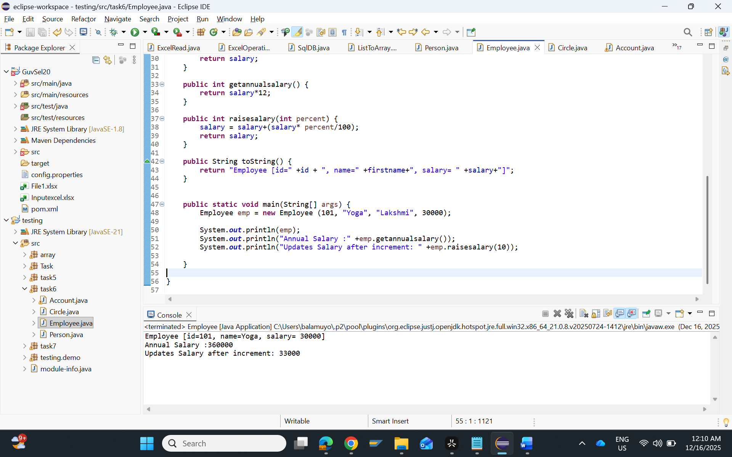

- Circle:
package task6;

public class Circle {

private double radius;

public Circle() {
radius =1.0;
}

public Circle(double radius) {
this.radius = radius;
}

public double calculatecircum() {
return 2*Math.PI*radius;
}

public static void main(String[] args) {

Circle circle1 = new Circle();
System.out.println("Circumference default radius:" + circle1.calculatecircum());

Circle circle2 = new Circle(6.01);
System.out.println("Circumference new radius:" + circle2.calculatecircum());
}

}
O/P:
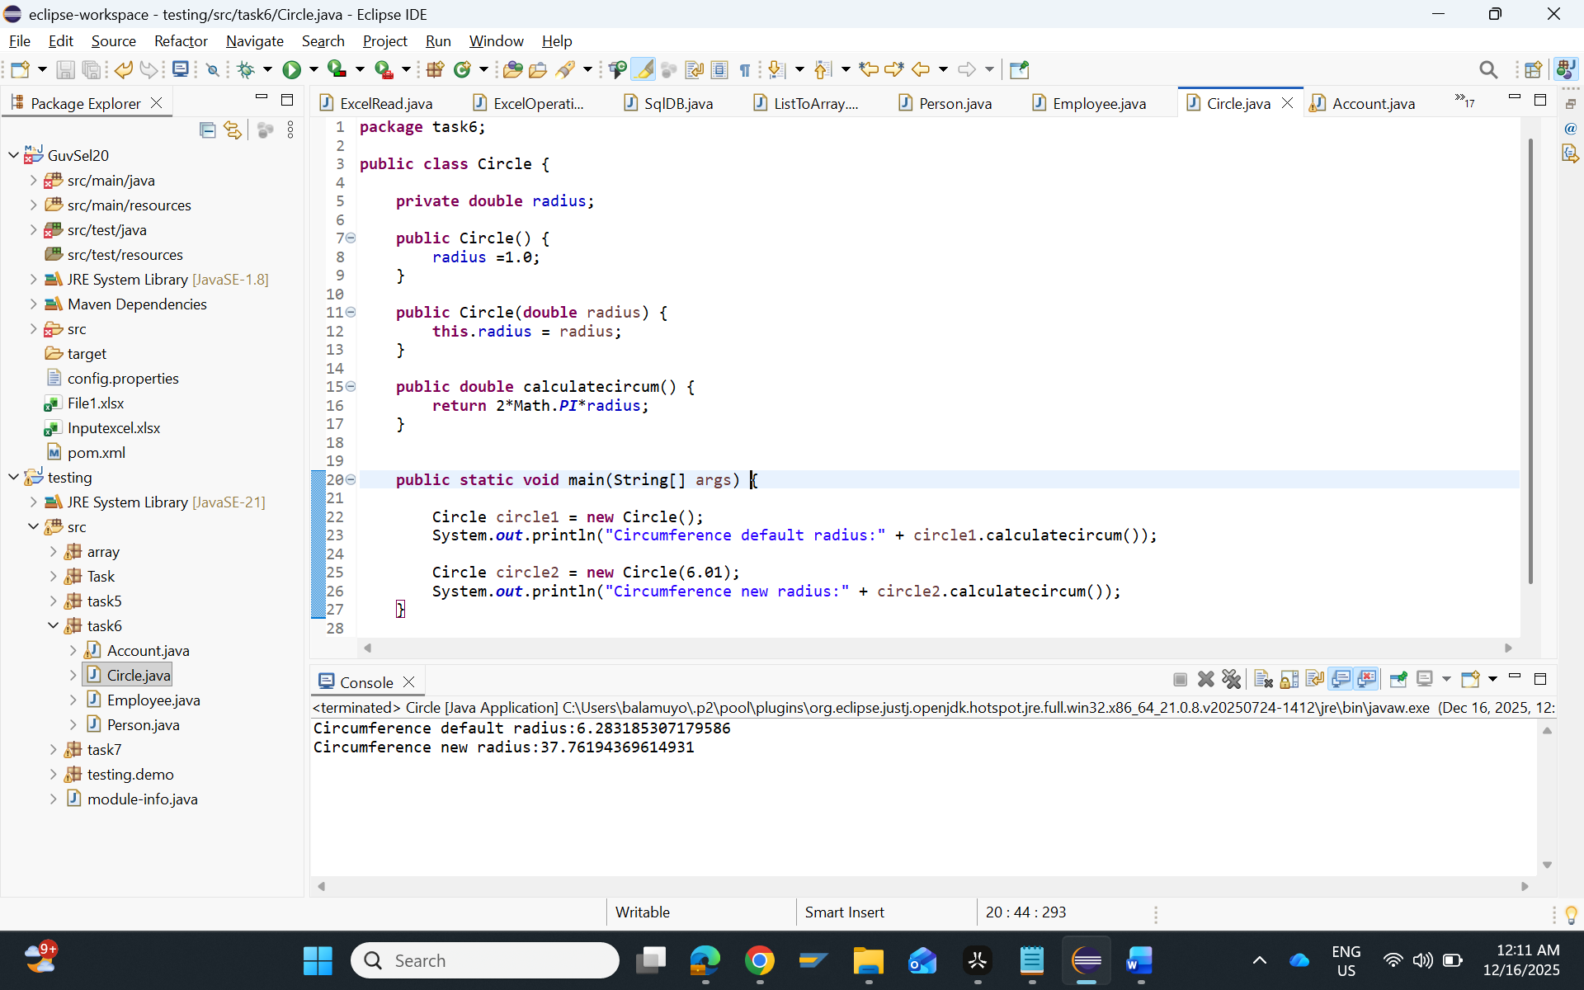

- Bank Account:
package task6;

public class Account {

private int accountnumber;
private double balance;

public Account() {
accountnumber = 0;
balance=0.00;
}

public Account (int accountnumber, double balance) {
this.accountnumber=accountnumber;
this.balance=balance;
}

public void deposit (double amount) {

balance = balance + amount;
System.out.println("Amount deposit" +amount);

}

public void withdraw(double amount) {
if(amount<=balance) {
balance = balance - amount;
System.out.println("Amount withdrawn:" + amount);
}else {
System.out.println("Insufficient balance");
}
}

public double checkbalance() {
return balance;
}

public static void main(String[] args) {
Account a1 = new Account();
a1.deposit(1000);
a1.withdraw(500);
System.out.println("Current balance a1:" +a1.checkbalance());

Account a2 = new Account(101,10000);
a2.deposit(2000);
a2.withdraw(3000);
System.out.println("Current balance a2:" +a2.checkbalance());

}

}

O/P:
